SECTION 1: Identification of the substance/mixture and of the company/undertaking
1.1 |  | Product identifier
 |  | Name: |  |  |  |  | NnF CERAM® SiO₂
 |  | Chemical name: |  |  |  |  | Silica, vitreous
 |  | CAS number: |  |  |  |  | 60676-86-0
 |  | EC number: |  |  |  |  | 262-373-8
 |  | Form: |  |  |  |  | Nanoform
1.2 |  | Relevant identified uses of the substance or mixture and uses advised against
 |  | Identified uses: |  |  |  |  | dessicant, sorbet, catalyst carrier, fillter
 |  | Uses advised against: |  |  |  |  | use the mixture only for the purposes specified by the manufacturer. Otherwise, the user may be exposed to unpredictable risks.
1.3 |  | Details of the supplier of the safety data sheet
 |  | Supplier: |  |  |  |  | PARDAM NANO4FIBERS s.r.o.  Žižkova 2759  Roudnice nad Labem 41301  Czech Republic
 |  | Telehone: |  |  |  |  | +420565552610
 |  | Responsible person: |  |  |  |  | ENVI GROUP s.r.o., Příčná 2186, 347 01 Tachov, Czech Republic  tel.: +420606638325, email: info@envigroup.cz
1.4 |  | Emergency telephone number
Call your national emergency center.
Universal emergency telephone number EU: 112

SECTION 2: Hazards identification
2.1 |  | Classification of the substance or mixture
 |  | Classification 1272/2008/WE: |  |  |  |  |  |  |  |  |  | The substance is classified as dangerous.
Carc. 1A, H350 (inhalation)
STOT RE 1, H372 (respiratory tract, inhalation)
STOT SE 3, H335
Eye Irrit. 2, H319
Skin Irrit. 2, H315
Acute Tox. 4, H302
 |  | Dangerous health effects: |  |  |  |  |  |  |  |  |  | May cause cancer. Causes damage to organs through prolonged or repeated exposure. May cause respiratory irritation. Causes serious eye irritation. Causes skin irritation. Harmful if swallowed.
 |  | Dangerous effects on the environment: |  |  |  |  |  |  |  |  |  | not classified
 |  | Dangerous physical-chemical effects: |  |  |  |  |  |  |  |  |  | not classified
2.2 |  | Label elements
 |  | Contains: |  |  |  |  |  | Silica, vitreous, CAS 60676-86-0
 |  | Hazard pictogram: |  |  |  |  |  | 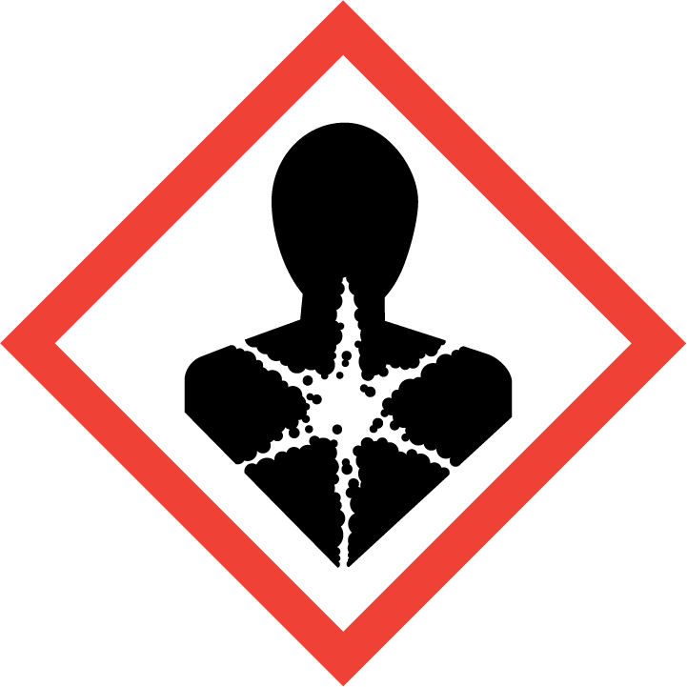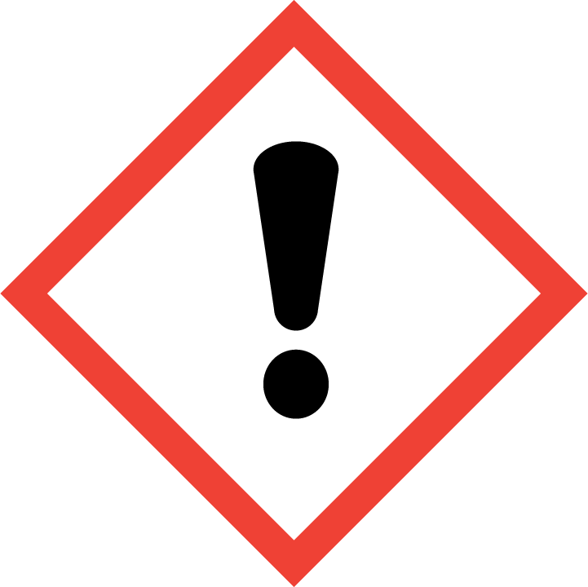
 |  | Signal word: |  |  |  |  |  | Danger
 |  | Hazard statement: |  |  |  |  |  | H350 May cause cancer.  H372 Causes damage to organs through prolonged or repeated exposure.  H335 May cause respiratory irritation.  H319 Causes serious eye irritation.  H315 Causes skin irritation.  H302 Harmful if swallowed.
 |  | Precautionary statements: |  |  |  |  |  | P201 Obtain special instructions before use.  P260 Do not breathe dust.  P280 Wear protective gloves/protective clothing/eye protection.  P301+P312 IF SWALLOWED: Call a POISON CENTER/doctor if you feel unwell.  P308+P313 IF exposed or concerned: Get medical advice/attention.  P304+P340 IF INHALED: Remove person to fresh air and keep comfortable for breathing.  P405 Store locked up.  P501 Dispose of contents/container in accordance with local regulations.
2.3 |  | Other hazards
 |  | The substance is not assessed as PBT or vPvB.
SECTION 3: Composition/information on ingredients
3.1 |  | Substances
Substance identifier |  |  |  |  |  |  |  |  |  | CAS number  EC number  Index number  Registration number |  |  | Content (%) |  |  | Classification 1272/2008
Silica, vitreous |  |  |  |  |  |  |  |  |  | 60676-86-0  262-373-8  -  - |  |  | ≤ 100 |  |  | Carc. 1A, H350 (inhalation)  STOT RE 1, H372 (respiratory tract, inhalation)  STOT SE 3, H335  Eye Irrit. 2, H319  Skin Irrit. 2, H315  Acute Tox. 4, H302
3.2 |  | Mixtures  Does not apply.
Full text of hazard statement is specified in chapter 16.
SECTION 4: First aid measures
4.1 | Description of first aid measures
4.1 | First aid personnel must take care on their own safety. In case of accident or if you feel unwell, or in case of the occurrence of any symptoms or doubts, consult your health condition with a doctor and provide information from this safety data sheet. In case of unconsciousness place the affected person into the stabilized position on the side and do not administer any oral products.
4.1 | Inhalation: |  |  |  | In case of inhalation, remove the person to fresh air. If not breathing, give artificial respiration. Consult a doctor.
4.1 | Skin contact: |  |  |  | Remove contaminated clothing, wash contaminated skin thoroughly with soap and water. If the problem persists, see a doctor.
4.1 | Eye contact: |  |  |  | Rinse open eyes immediately with water for about 15 minutes, do not rinse with a strong stream of water - risk of corneal injury. Consult a doctor.
4.1 | Ingestion: |  |  |  | Do not induce vomiting. Rinse mouth with water. Consult a doctor.
4.2 | Most important symptoms and effects, both acute and delayed  May irritate the respiratory tract, skin and eyes. Causes damage to organs through prolonged or repeated exposure. May cause cancer.
4.3 | Indication of any immediate medical attention and special treatment needed
4.3 | Special funds are not intended. Treatment is symptomatic.
SECTION 5: Firefighting measures
5.1 | Extinguishing media
5.1 | Suitable extinguishing media: |  |  |  |  |  |  |  |  |  | fire extinguishing agents adapt to the surrounding fire
5.1 | Unsuitable extinguishing media: |  |  |  |  |  |  |  |  |  | strong stream of water
5.2 | Special hazards arising from the substance or mixture
5.2 | In case of fire, carbon dioxide, carbon monoxide and other dangerous gases may be formed.
5.3 | Advice for firefighters
5.3 | Use complete protective equipment.
SECTION 6: Accidental release measures
6.1 | Personal precautions, protective equipment and emergency procedures
6.1 | Restrict unauthorized access to the accident area until the accident is rectified. Ensure adequate ventilation. Avoid contact with skin and eyes. Avoid dust inhalation. Follow the rules and regulations of work safety when working with chemical products. Use personal protective equipment.
6.2 | Environmental precautions
6.2 | Do not allow to enter sewers / surface or ground water. If the product leaks into water or sewage system inform appropriate authorities.
6.3 | Methods and material for containment and cleaning up
6.3 | Collect and dispose of without creating dust (wet wipping). Store in suitable closed containers for disposal. Dispose of collected material in accordance with local regulations.
6.4 | Reference to other sections
6.4 | Section 8 and 13.
SECTION 7: Handling and storage
7.1 | Precautions for safe handling
7.1 | Avoid dust formation. Ensure good ventilation and extraction at the workplace. Do not breathe dust. Avoid contact with eyes and skin. For personal protection see section 8. Do not drink, eat or smoke while using this product. Wash hands after use.
7.2 | Conditions for safe storage, including any incompatibilities
7.2 | Store in closed containers in a dry, ventilated place. Do not eat, drink or smoke in areas where the product is stored and used. Protect from direct sunlight. Do not store with food, drinks and feed.
7.3 | Specific end use(s)
7.3 | Information not available
SECTION 8: Exposure controls/personal protection
8.1 | Control parameters
8.1 | Occupational exposure limit values: not available  DNEL - information not available  PNEC - information not available
8.2 | Exposure controls
8.2 | Ensure adequate ventilation. Ensure that persons using personal protective equipment work with the product. After work, wash your hands thoroughly with soap and water. Do not eat, drink or smoke while working.  The monitoring procedure for the content of substances in the workplace air and the specification of protective equipment shall be determined by the worker responsible for occupational safety and health protection.
8.2 | Individual protection measures, such as personal protective equipment
8.2 | Respiratory protection: |  |  |  |  | Face masks (FP2 or FP3)
8.2 | Eye protection: |  |  |  |  | Safety goggles
8.2 | Hand protection: |  |  |  |  | Wear protective gloves. The glove material has to be impermeable and resistant to the product. Consult the manufacturer for the choice of gloves.
8.2 | Skin protection: |  |  |  |  | Suitable work clothes and shoes
8.2 | Environmental exposure controls
8.2 | Prevent leakage to the sewage system, surface waters, underground waters and soil.
SECTION 9: Physical and chemical properties
9.1 | Information on basic physical and chemical properties
9.1 | Physical state |  |  |  |  |  |  |  |  |  |  |  |  |  | Solid (filaments)
9.1 | Colour |  |  |  |  |  |  |  |  |  |  |  |  |  | White
9.1 | Color intensity |  |  |  |  |  |  |  |  |  |  |  |  |  | Light
9.1 | Odour |  |  |  |  |  |  |  |  |  |  |  |  |  | without fragrance (nanoform)
9.1 | Melting point/freezing point (°C): |  |  |  |  |  |  |  |  |  |  |  |  |  | >400 °C (nanoform)
9.1 | Boiling point or initial boiling point and boiling range (°C): |  |  |  |  |  |  |  |  |  |  |  |  |  | data not available
9.1 | Flammability |  |  |  |  |  |  |  |  |  |  |  |  |  | data not available
9.1 | Lower and upper explosion limit:  upper limit (% vol.):  lower limit (% vol.): |  |  |  |  |  |  |  |  |  |  |  |  |  | data not available
9.1 | Flash point (°C): |  |  |  |  |  |  |  |  |  |  |  |  |  | data not available
9.1 | Auto-ignition temperature |  |  |  |  |  |  |  |  |  |  |  |  |  | data not available
9.1 | Decomposition temperature |  |  |  |  |  |  |  |  |  |  |  |  |  | data not available
9.1 | pH |  |  |  |  |  |  |  |  |  |  |  |  |  | non-soluble (in water)
9.1 | Kinematic viscosity |  |  |  |  |  |  |  |  |  |  |  |  |  | data not available
9.1 | Solubility |  |  |  |  |  |  |  |  |  |  |  |  |  | it is not soluble in water(nanoform)
9.1 | Partition coefficient n-octanol/water (log value) |  |  |  |  |  |  |  |  |  |  |  |  |  | data not available
9.1 | Vapour pressure |  |  |  |  |  |  |  |  |  |  |  |  |  | data not available
9.1 | Density |  |  |  |  |  |  |  |  |  |  |  |  |  | 3.9 - 4.26 g/cm³ at 20 °C (nanoform)
9.1 | Relative vapour density |  |  |  |  |  |  |  |  |  |  |  |  |  | data not available
9.1 | Particle characteristics |  |  |  |  |  |  |  |  |  |  |  |  |  | filaments
9.2 | Other information
9.2 | data not available
SECTION 10: Stability and reactivity
10.1 | Reactivity
10.1 | Chemically stable in acids (except hydrofluoric acid, HF), in alkaline environements it forms silicates, when dry, it readily adsorbs water vapours
10.2 | Chemical stability
10.2 | Stable except in HF, fluorine environment and in strong basesstal
10.3 | Possibility of hazardous reactions
10.3 | Not available
10.4 | Conditions to avoid
10.4 | Exposure to temperatures above 1000°C, exposure to flourine
10.5 | Incompatible materials
10.5 | Not available
10.6 | Hazardous decomposition products
10.6 | Siliconon fluoride (SiF4) upon reaction with flourine
SECTION 11: Toxicological information
11.1 | Information on hazard classes as defined in Regulation (EC) No 1272/2008
a) Acute toxicity
Harmful if swallowed.
 | b) |  | Skin corrosion/irritation
 |  |  | Causes skin irritation.
 | c) |  | Serious eye damage/irritation  Causes serious eye irritation.
 | d) |  | Respiratory or skin sensitisation  Based on available data, the classification criteria are not met.
 | e) |  | Germ cell mutagenicity
 |  |  | Based on available data, the classification criteria are not met.
 | f) |  | Carcinogenicity
 |  |  | May cause cancer.
 | g) |  | Reproductive toxicity
 |  |  | Based on available data, the classification criteria are not met.
h) STOT-single exposure
May cause respiratory irritation.
i) STOT-repeated exposure
Causes damage to organs through prolonged or repeated exposure.
j) Aspiration hazard
Based on available data, the classification criteria are not met.
11.2 | Information on other hazards  Information is not available
SECTION 12: Ecological information
12.1 | Toxicity  The substance is not classified as dangerous for the aquatic environment.
12.2 | Persistence and degradability
12.2 | Information not available.
12.3 | Bioaccumulative potential
12.3 | Information not available.
12.4 | Mobility in soil
12.4 | Information is not available
12.5 | Results of PBT and vPvB assessment
12.5 | The substance is not assessed as PBT or vPvB.
12.6 | Endocrine disrupting properties  Not known
12.7 | Other adverse effects
12.7 | Do not allow to enter drains, surface or ground water.
SECTION 13: Disposal considerations
13.1 |  | Waste treatment methods
 |  | a) | Suitable methods for removing the mixture and contaminated packaging:
 |  |  | Hand over the marked waste for disposal to a specialized company authorized for this activity. It must not be disposed of with municipal waste. Dispose of waste in accordance with local regulations.
 |  | b) | Specify the physical/chemical properties that may affect waste treatment options
 |  |  | information is not available
 |  | c) | Discourage sewage disposal
 |  |  | information is not available
 |  | d) | Iidentify, where appropriate, any special precautions for any recommended waste treatment option
 |  |  | information is not available
SECTION 14: Transport information
 |  | The product is not dangerous for transport
14.1 |  | UN number or ID number: The product is not dangerous for transport
14.2 |  | UN proper shipping name
 |  | Ground transportation ADR |  |  |  |  |  |  | -
 |  | Railway transportation RID
 |  | Naval transport IMDG:
 |  | Air transport ICAO/IATA:
14.3 |  | Transport hazard class(es)
 |  | ADR |  |  |  |  | RID |  |  |  |  |  |  | IMDG: |  |  | ICAO/IATA:
 |  | - |  |  |  |  | - |  |  |  |  |  |  | - |  |  | -
14.4 |  | Packing group
 |  | ADR |  |  |  |  | RID |  |  |  |  |  |  | IMDG: |  |  | ICAO/IATA:
 |  | - |  |  |  |  | - |  |  |  |  |  |  | - |  |  | -
14.5 |  | Environmental hazards
 |  | Substance is not hazardous to the environment during transport.
14.6 |  | Special precautions for user
 |  | The product is not dangerous for transport
14.7 |  | Maritime transport in bulk according to IMO instruments
 |  | Information is not available
SECTION 15: Regulatory information
15.1 |  | Safety, health and environmental regulations/legislation specific for the substance or mixture
 |  | Regulation (EC) No 1907/2006 (REACH), Regulation (EC) No 1272/2008 (CLP), Commission Regulation (EU) 2020/878, the Waste Act as amended
15.2 |  | Chemical safety assessment
 |  | A chemical safety assessment has not been performed.
SECTION 16: Other information
 |  | a) | Changes made to the safety data sheet on 23.10.2023: adapt of the safety data sheet according to Regulation (EC) No. 878/2020 of the European Parliament and of the Council and according to Regulation (EC) No. 1272/2008 of the European Parliament and of the Council
 |  | b) | List of abbreviations
 |  |  | DNEL | Derived No Effect Level
 |  |  | PNEC | Predicted No Effect Concentration
 |  |  | CLP | Regulation (EC) No 1272/2008
 |  |  | REACH | Regulation (EC) No 1907/2006
 |  |  | IMDG | International Code of Dangerous Goods
 |  |  | IATA | International Air Transport Association
 |  |  | ICAO | International Civil Aviation Organization
 |  |  | ADR | European Agreement concerning the International Carriage of Dangerous Goods by Road
 |  |  | RID | Regulation on the international transport of dangerous goods by rail
 |  |  | Einecs | European Inventory of Existing Commercial Chemical Substances
 |  |  | CAS | Chemical Abstracts Service
 |  |  | PBT | persistent, bioaccumulative and toxic substance
 |  |  | vPvB | very persistent a very bioaccumulation substance
 |  |  | SDS | Safety data sheet
 |  |  | Skin Irrit. 2 | Skin corrosion/irritation, category 2
 |  |  | Eye Irrit. 2 | Serious eye damage / eye irritation, category 2
 |  |  | STOT SE 3 | Specific target organ toxicity - single exposure, category 3, respiratory tract irritation
 |  |  | STOT RE 1 | Specific target organ toxicity - repeated exposure, category 1
 |  |  | Acute Tox. 4 | Acute toxicity (oral), category 4
 |  |  | Carc. 1A | Carcinogenicity, category 1A
 |  | c) | Sources of information
State legislation, original manufacturer's safety data sheets, ECHA website.
The classification was made by the manufacturer.
 |  | d) | List of hazard statements:
 |  | d) | H302 | Harmful if swallowed
 |  | d) | H335 | May cause respiratory irritation
 |  | d) | H319 | Causes serious eye irritation
 |  | d) | H315 | Causes skin irritation
 |  | d) | H372 | Causes damage to organs through prolonged or repeated exposure
 |  | d) | H350 | May cause cancer
 |  | e) | Instructions for training
 |  |  | Training of work safety for handling with chemicals.
 |  | f) | Other information
 |  |  | The information in this safety data sheet correspond to the best knowledge of the product at the time of publication. This information is used for safer handling, storage, transportation and disposal of the product. This information does not guarantee the quality of the product. This information applies only to this material and is not valid if the product is used in combination with other materials or in a way which is not listed in this SDS.

